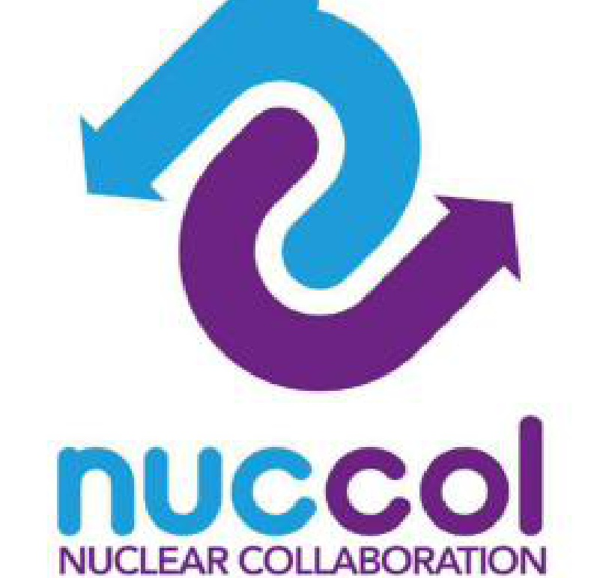
Product and Specification Control
Training Guide | PE-10c | Process Excellence | Fit For Nuclear Toolkit
Drawing and specification control, job travellers, change control, and traceability from material to finished part
Document control
Version | Date | Author | Summary of change
1.0 |  |  | First issue
1. Why product and specification control matters
Product and specification control is how a company makes sure that everyone making, checking, and shipping a part is working from the same, current information about what that part is supposed to be. It covers the drawings and specifications themselves, the job cards or travellers that carry instructions through the shopfloor, and the process for managing changes when a drawing or specification is revised.
Almost every serious quality problem in manufacturing can be traced back, in some part, to a mismatch between what was made and what was specified. Sometimes the part was made correctly to an old revision that had since changed. Sometimes the work instruction did not reflect the latest drawing. Sometimes a verbal change was agreed and never written down. Product and specification control exists to close these gaps.
One principle above all: if you cannot point to the exact drawing or specification revision a part was made to, and show that it was the current revision at the time, you cannot demonstrate the part is correct, however good it actually is.

What good product and specification control looks like
- A single, known-current revision of every drawing and specification, with a register that says what that revision is.
- A job card or traveller system that links each part or batch to the drawing, specification, and revision it was made to.
- A controlled process for raising, assessing, approving, and implementing changes, so nothing changes informally.
- Obsolete revisions removed from the shopfloor the moment a new revision is issued.
- Full traceability: for any part, you can show what material it was made from, what revision it was made to, who made and checked it, and what the inspection results were.

Why this matters for F4N
Product and Specification Control is one of the ten Process Excellence themes assessed under the Fit For Nuclear programme. Assessors look at how job cards, travellers, and drawings are managed in production, and expect a written procedure or process map explaining how specification changes are controlled, alongside a controlled drawing register or revision system. In a nuclear supply chain, this extends further: customers will expect full traceability to component and material level, certificates of conformance that reference the correct drawing and revision, and a documented process for categorising and resolving any deviation from specification.
2. The documentation hierarchy
Product and specification control rests on a hierarchy of documents, each with a different purpose. Understanding where each one sits, and what it depends on, is the foundation for keeping everything in step.
Document | What it defines | Who controls it
Customer drawing / specification | The product itself: dimensions, tolerances, material, finish, and any flagged Critical or key characteristics. | The customer, or the company's design function where design responsibility sits with the company. Changes require the same level of review as the original issue.
Internal drawing / specification | Any internal interpretation, sub-assembly drawing, or material specification derived from the customer document. | The company's engineering or technical function, but must remain consistent with the customer document at all times.
Work instruction / SOP (PE-06) | How a specific task is carried out at a specific workstation, step by step. | The company, but must reflect the current drawing and specification revision. A work instruction referencing an old revision is itself a non-conformance.
Process control plan (PE-09a) | What is checked, how, and how often, for each characteristic. | The company, linked to drawing and specification revisions for the characteristics it controls.
Job card / traveller | The specific instance: this part, this batch, this material, made to this drawing revision, checked against this control plan. | Generated for each job or batch, referencing the current revisions of everything above at the point the job is released.

A change at any level of this hierarchy can mean changes are needed at every level below it. A drawing revision can mean the work instruction, the control plan, and every open job card need updating too. Product and specification control is about managing that cascade deliberately, not discovering it after the fact.
3. The drawing and specification register
The drawing and specification register, PE-10a, is the single source of truth for which revision of every controlled drawing, specification, work instruction, and customer document is currently valid. If a document is not in the register, or is in the register at a different revision to the one on the shopfloor, that is a control gap that needs closing immediately.

What goes in the register
- Every drawing and specification used in production, whether issued by the customer, by a subcontractor, or internally.
- The current revision and the date it became current.
- Where each document is used: which parts, which process steps, so that when a revision changes, everyone affected can be identified quickly.
- The status of each item: Active, Superseded, Withdrawn, or Under Review.
- A link to the Change Notice (PE-10b) that introduced the current revision, so the history of why it changed is traceable.

Keeping the register honest
A register is only useful if it reflects reality. The two things most likely to cause a register to drift out of step with the shopfloor are informal changes that are never logged, and superseded copies that are never removed from where they are used. PE-10a includes a Point of Use Check sheet specifically for catching this second problem: a simple audit that compares what is physically at a workstation with what the register says is current.
Run the Point of Use Check regularly, not just before an audit. The value of catching a superseded drawing on the wall is in catching it before it is used to make a part, not in catching it before an assessor walks the floor.

Review dates
Every item in the register should have a review date, even items that rarely change. A review is an opportunity to confirm the item is still correct, still in use, and still needed, not just a formality. PE-10a calculates the time remaining to each review date automatically, so overdue and approaching reviews are visible at a glance.
4. Job cards and travellers
A job card, traveller, or route card is the document that accompanies a part or batch through production. Whatever it is called on a given site, its purpose is the same: it tells the people working on the part what it is, what it should be made to, what process it should follow, and it captures evidence that each step was completed and checked.

What a job card or traveller should reference
- The part number, drawing number, and the specific revision the job has been released against.
- The material specification and batch or cast number, for traceability back to the material certificate.
- The process route: the sequence of operations the part follows, matching the process control plan (PE-09a).
- Inspection points: where checks happen, linked to the in-process inspection record (PE-09b).
- Sign-off fields for each step, so there is a record of who did what and when.

Why the revision on the job card matters
The job card or traveller is generated when a job is released to production, and it should capture the drawing and specification revisions that were current at that moment. If a revision changes after a job has been released but before it is complete, the impact on any open job cards is one of the questions the impact assessment in PE-10b is designed to surface.
- If the change does not affect work already done or in progress, the job can usually continue to the original revision, with this decision recorded.
- If the change does affect work in progress, a decision is needed: complete to the old revision and address the gap separately, or stop and rework to the new revision. This decision should be made deliberately, not left to whoever happens to be at the machine when the new drawing arrives.

Traceability through the job card
A complete job card, properly filled in, is what makes traceability possible after the fact. If a customer raises a concern about a part months after it shipped, the job card (or its digital equivalent) should be able to answer: what material was it made from, what drawing revision, who carried out each step, what were the inspection results, and was anything out of specification at any point. Where any of these questions cannot be answered, that is a traceability gap worth addressing before it becomes a problem during an audit or a customer investigation.
5. Managing specification changes
Every change to a drawing, specification, or work instruction should follow the same controlled path, using PE-10b, the Specification Change Request and Change Notice form. The form has one structure, but it is used differently depending on where the change is in its life: as a request, as an assessment, as an approval record, and finally as the implementation and close-out record.
Stage | What happens
Request | Anyone can raise a Specification Change Request (SCR): an operator who has spotted a problem, a customer issuing a revised drawing, or an engineer proposing an improvement. The request describes exactly what needs to change and why.
Impact assessment | Before any approval, every area that could be affected is checked: other drawings, tooling, the control plan, stock, training, and customer notification. This step is what prevents a document edit turning into an unplanned non-conformance somewhere else.
Approval | Relevant functions, typically engineering, quality, and production, review the impact assessment and approve, approve with conditions, reject, or defer the change. Customer approval is sought where required.
Change Notice and implementation | Once approved, the new revision is issued, and the Change Notice records what was issued, when, and by whom. This is the reference used in the drawing register's change log.
Implementation checklist | Everything identified in the impact assessment is worked through: documents updated, obsolete copies removed, tooling and gauges updated, stock dispositioned, people trained, and the register updated.
Close-out | The change is signed off as complete only once every applicable item on the checklist is done. An open change with outstanding actions is a control gap, even if the new drawing has been issued.

The most dangerous changes are often the smallest. A one-line wording change to a work instruction can be just as significant as a major dimensional change if it changes how a Critical characteristic is checked. Every change goes through the same process, regardless of how small it looks.

Common triggers for a specification change
- A customer issues a revised drawing or specification, often following their own design review or a fit issue identified elsewhere in their supply chain.
- A root cause investigation (PE-04) identifies that the specification itself, not just the process, needs to change.
- A process or tooling change means the existing specification can no longer be met as written, or can now be met more efficiently.
- An improvement idea from the team would benefit the product or process, and is proposed as a change rather than implemented informally.
- An error is found in an existing document: a wrong dimension, an inconsistent reference, or an outdated cross-reference to another document.
6. Deviations and concessions
A deviation, sometimes called a concession or a non-conformance depending on the terminology used, is an unplanned departure from the specified requirement, identified through inspection, audit, or any other means. A deviation is different from a specification change: a specification change is a deliberate, planned update to what is required; a deviation is something that has already happened that does not meet what was required.

Why deviations are not a bad thing to report
Industry guidance for the nuclear supply chain is consistent on this point: identifying and reporting deviations should be seen as a positive indication that the importance of meeting requirements is understood, not as something to be hidden or minimised. The alternative, where deviations are not identified or reported, is far more serious, because it means non-conforming product can reach the next stage of the supply chain, or the customer, without anyone being aware.
A site with zero recorded deviations is not necessarily a site with no problems. It may be a site where problems are not being found, or are not being reported. A healthy level of recorded and resolved deviations is a sign the controls are working, not a sign they are failing.

How deviations connect to the rest of the toolkit
- A deviation found during in-process inspection (PE-09b) follows the reaction plan set out in the process control plan (PE-09a): stop, contain, notify, as appropriate to the classification of the characteristic involved.
- Where a deviation needs investigation beyond a simple reject and rework, it should be raised through PE-04, problem solving and root cause analysis, so the underlying cause is addressed.
- Where the cumulative effect of a deviation, or a pattern of deviations, suggests the specification itself needs to change, this becomes a Specification Change Request (PE-10b), with the deviation history as part of the reason for change.
- Any deviation that could affect a part already supplied, or that requires customer awareness, should be escalated according to the contractual requirements for that customer, which may include formal concession requests before any non-conforming product can be released.
7. Putting this into practice
This section brings together the practical steps for establishing or strengthening product and specification control. It is intended as a starting point for discussion, not a checklist to complete in isolation.

Getting started
- Build the drawing and specification register (PE-10a) for everything currently in use, even if it means an initial effort to track down current revisions. An incomplete register is better than no register, as long as the gaps are known and being closed.
- Walk the shopfloor and check what is actually at each workstation against the register, using the Point of Use Check. Any mismatch found at this stage is valuable information, not a failure.
- Agree the format for job cards or travellers, and make sure every open job references a drawing and specification revision that matches the register.
- Introduce the Specification Change Request and Change Notice (PE-10b) for all future changes, however small, and retire any informal change processes that have been used in the past.
- Set review dates for everything in the register, spread sensibly across the year rather than all falling due at once.

Signs it is working
- Anyone can be asked 'what revision should this drawing be at' and the answer matches both the register and what is physically at the workstation.
- Specification changes are rare events that are well documented, rather than frequent informal adjustments that nobody can fully account for.
- Job cards and travellers consistently reference current revisions, with no gaps when checked.
- Deviations are reported routinely and without hesitation, and lead to visible follow-up action.

Signs it needs attention
- Different copies of the same drawing, at different revisions, can be found in different places.
- Changes are made by updating a document and telling people verbally, without a Change Notice.
- Job cards reference a drawing number but not a revision, or the revision shown does not match the register.
- Deviations are rarely reported, or are resolved informally without a record.
8. Toolkit documents
- PE-10a Drawing and Specification Register: the live register of current drawing and specification revisions, with a change log and point of use audit tool
- PE-10b Specification Change Request / Change Notice: the controlled form for requesting, assessing, approving and implementing a change
- Related: PE-04 problem solving and RCA (deviations and root cause), PE-06 standard operating procedures (work instructions kept in step with specifications), PE-08 operational communication (cascading changes to teams), PE-09 process control (control plans kept in step with specifications)

